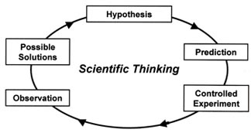
Learning Guide
Biology Chapter 1
The Nature of Biology
Essential Questions:
How do scientists use the scientific method to explain the world around them?
What are the characteristics of life?
How does technology continually change how scientists work?

Activities:
- Scientific method activity
- Microscope Lab
- Scientific Process Flow Chart

Mitochondria
Chloroplast
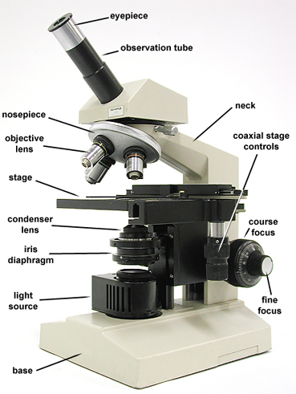
Learning Targets: I can…
understand the characteristics of life and diversity in the biosphere.
explain how scientists use scientific method/processes to explain the natural world.
use science skills and technology to conduct ethical scientific investigations.

1.1 Study of Life
Biology |  |  | Organism
Biodiversity |  |  | Cell
Species |  |  | Metabolism
Biosphere |  |  | DNA
1.2 Unifying Themes of Biology
System Ecosystem
Homeostasis Evolution Adaptation
1.3 Scientific Thinking and Processes
Observation |  |  | Independent Variable
Data |  |  | Dependent variable
Hypothesis |  |  | Constant
Experiment |  |  | Theory
1.4 Biologist Tools and Technology
Light Microscope/micrograph
Transmission Electron Microscope/micrographs
Scanning Electron Microscope/micrographs

